TEMA: School
- Задание на 10 очков.
Read the sentences using the words instead pictures.
Answer: 1. I usually wear a red t-shirt and blue shorts in summer.
2. When it is cold I put on my grey sweater and my yellow jacket.
- Задание на 20 очков.
Name 5 words, associated with school.
- Задание на 30 очков.
Find mistakes
- She goes to school every day.
- I like this these boots.
- What would you like?- I ‘d like this scarf

- Задание на 40 очков.

Read the transcription and write down the words

- |ˈrʌʃ(ə)n| Russian
- |mæθs| Maths
- |ˈmjuːzɪk| Music

- Задание на 50 очков
Find the words hidden in the charts. 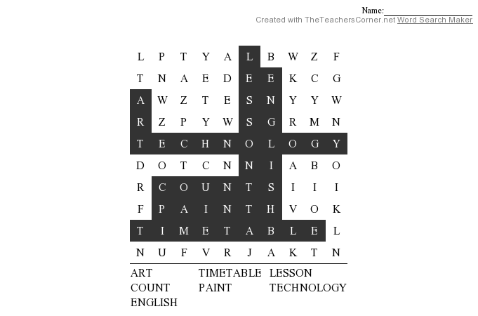
TEMA:World
- Задание на 10 очков.
Answer the questions: What is the weather in Paris? What is the weather in Moscow?.
Answer: 1. It’s warm and cloudy in Paris. 2.It’s cold and snowy in Moscow.
- Задание на 20 очков.
Put days in the correct order.
Wednesday 3 , Saturday 5, Monday 1, Friday 4, Tuesday 2
- Задание на 30 очков.
Make the correct form.
1. Mike is ____(tall) than Liz. taller
2. This rose is_____ (beautiful) than that rose. More beautiful
3. My teacher is ____ (good). The best

- Задание на 40 очков.

Read the transcription and write down the words

- 1. |hɔːl| hall
- 2. |ˈbɑːθruːm| bathroom
- 3. |haʊs| haus

- Задание на 50 очков
Find the words hidden in the charts.

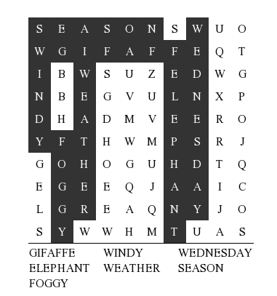

TEMA: Time
- Задание на 10 очков.
Answer the questions: What time is it?
Answer: 1. It’s 15.55; 2. It’s 14.25
- Задание на 20 очков.
Put numerals in the correct order.
4, 12, 19, 23, 56
- Задание на 30 очков.
Make sentences.
- do/morning/do/what/in/the/you? ( What do you do in the morning?)
- get up/your/does/at/7 o’clock/mother? (Does your mother get up at 7 o’clock?)
- bed/go/to/do/when/you/usually? (When do you usually go to bed?)

- Задание на 40 очков.

Read the transcription and write down the words

1. |ˈɡrændæd| granddad
2. |ˈtʃɪldrən| children
3. |ˈmʌðə| mother

- Задание на 50 очков
Find the words hidden in the charts.

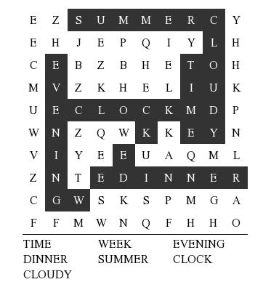

TEMA: Secret
- Задание на 10 очков.
Musical pause
- Задание на 20 очков.
Name 5 members of the family
- Задание на 30 очков.
Tell the correct form..
1. Mike is number 1. He is ____. The first
2. Liz is number 3. She is ____. The third
3. We are number 5. We are ____, the fifth .

- Задание на 40 очков.

Read the transcription and write down the words

- |mjuːˈzɪəm| Museum
- |ˈsɪnəmə| cinema
- |ˈdɪskəʊ| disco

- Задание на 50 очков
Find the words hidden in the charts.
